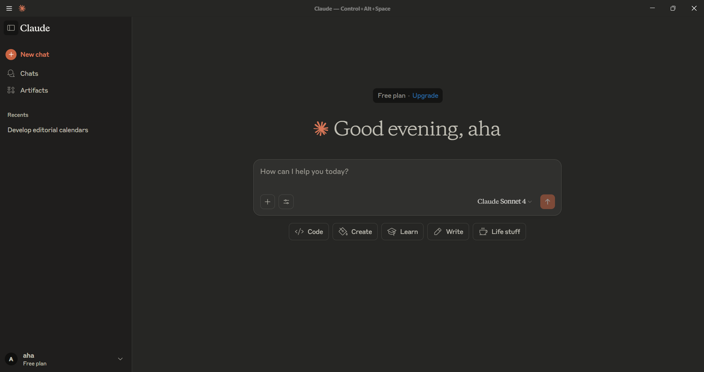

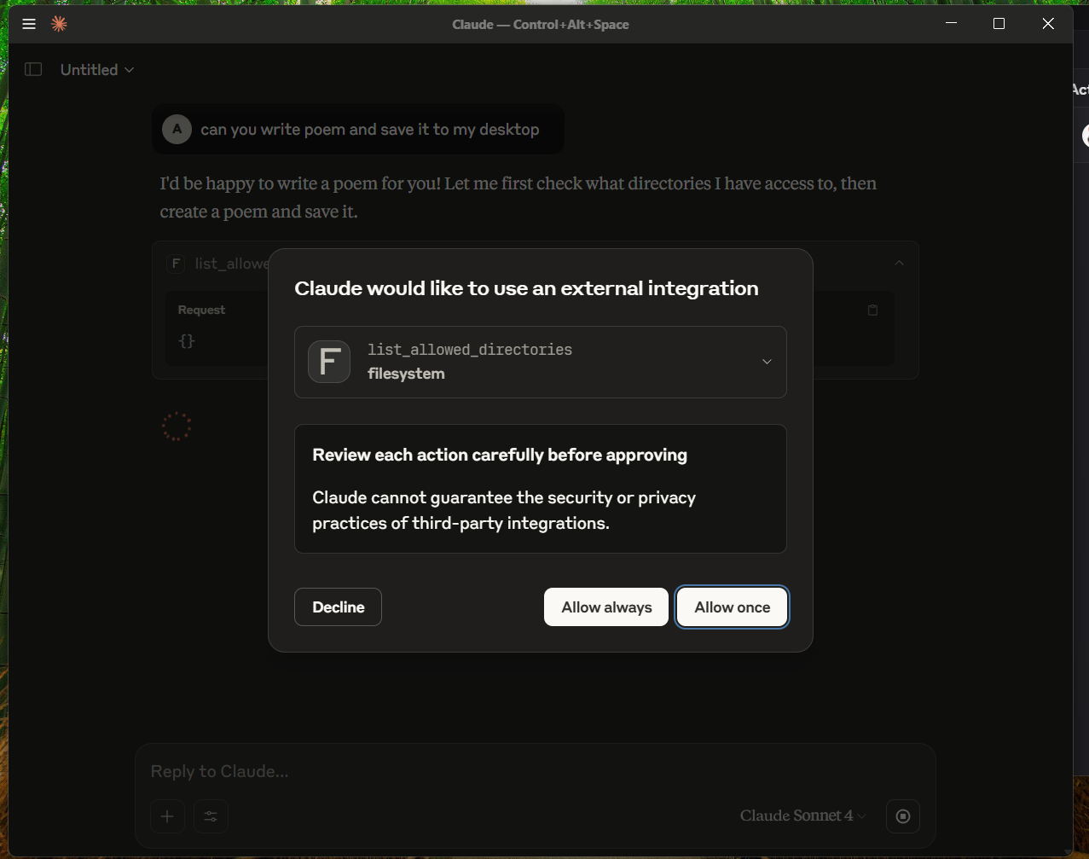

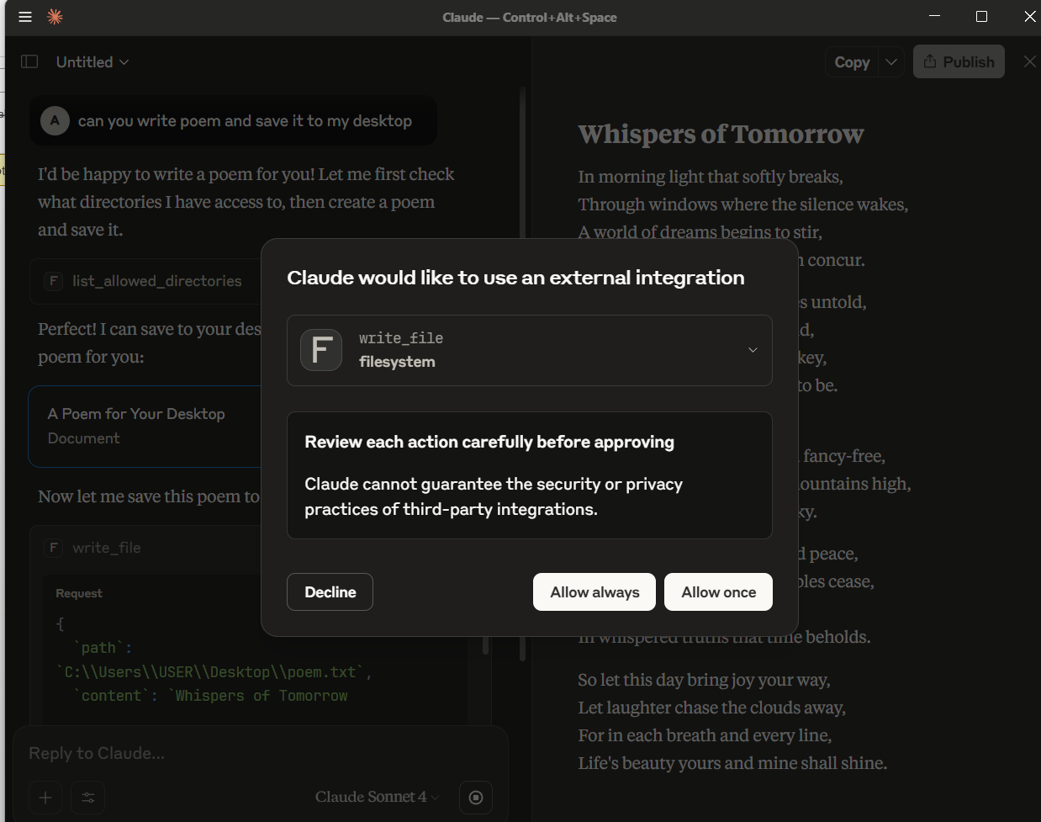

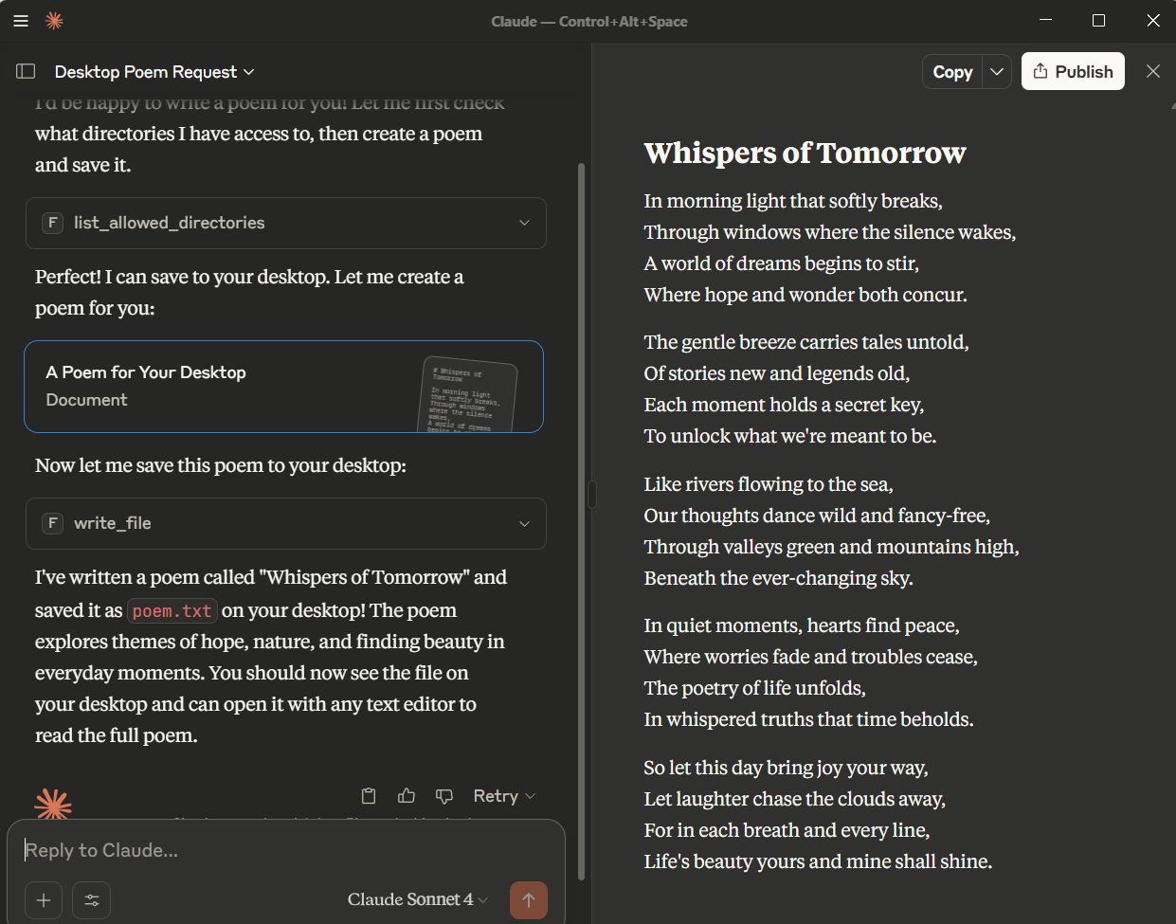

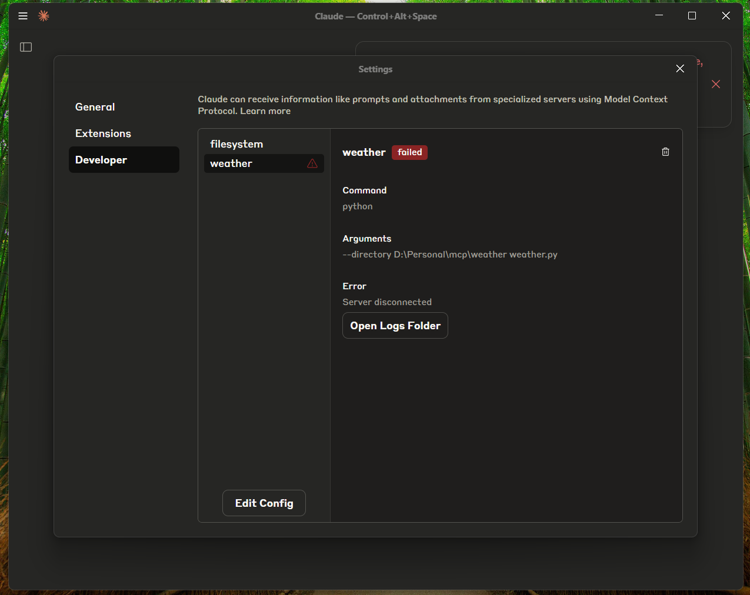

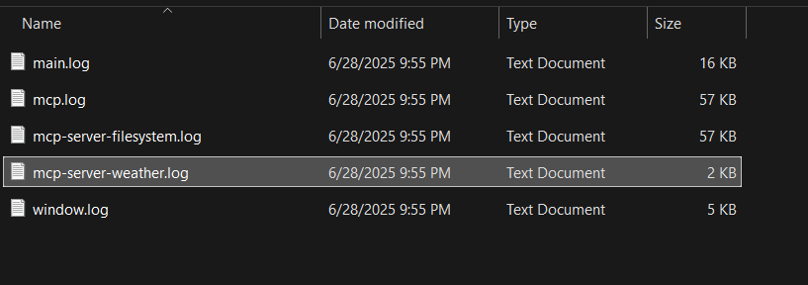

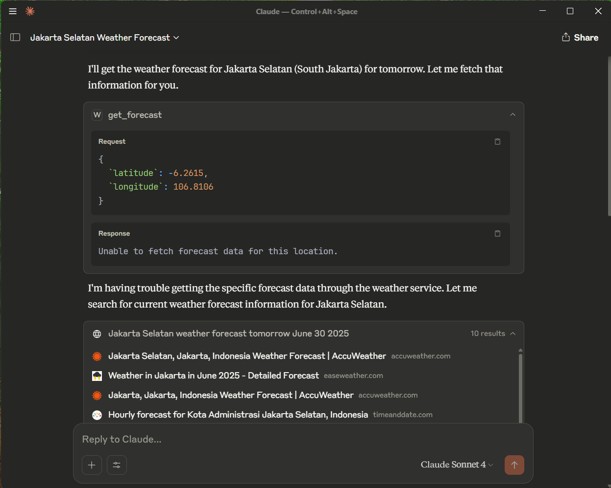

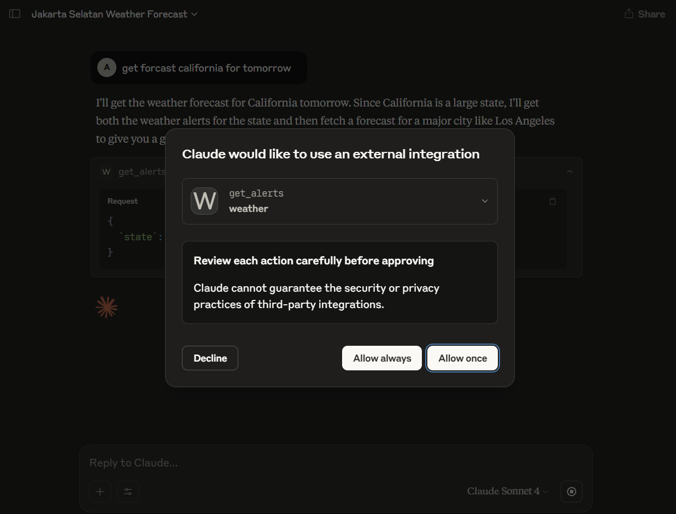

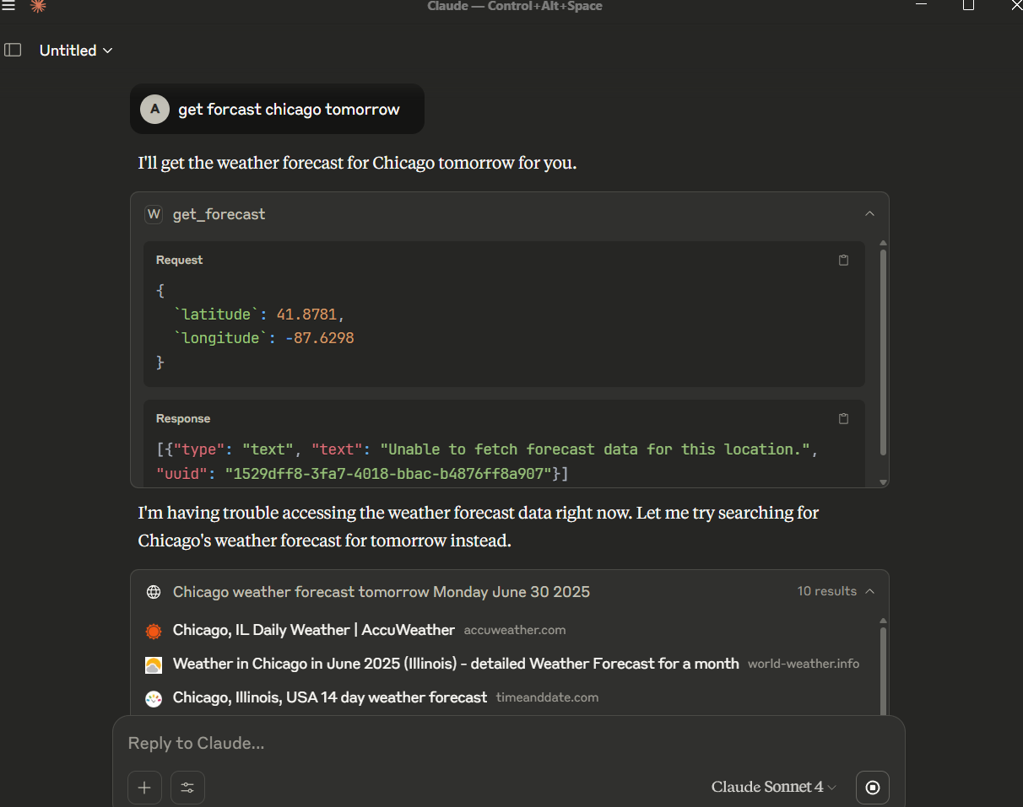

Console dengan inspector :

PS D:\Personal\mcp> npx @modelcontextprotocol/inspector --directory "D:\\Personal\mcp\weather.py"

Need to install the following packages:

@modelcontextprotocol/inspector@0.14.3

Ok to proceed? (y) y

Starting MCP inspector...

🔍 MCP Inspector is up and running at http://127.0.0.1:6274 🚀

node:internal/util/parse_args/parse_args:87

throw new ERR_PARSE_ARGS_INVALID_OPTION_VALUE(errorMessage);

^

TypeError [ERR_PARSE_ARGS_INVALID_OPTION_VALUE]: Option '--env' argument is ambiguous.

Did you forget to specify the option argument for '--env'?

To specify an option argument starting with a dash use '--env=-XYZ'.

gs:87:11)

at node:internal/util/parse_args/parse_args:382:9

at Array.forEach (<anonymous>)

at parseArgs (node:internal/util/parse_args/parse_args:378:3)

at file:///C:/Users/USER/AppData/Local/npm-cache/_npx/5a9d879542beca3a/node_modules/@modelcontextprotocol/inspector/server/build/index.js:24:20

at ModuleJob.run (node:internal/modules/esm/module_job:262:25)

at async onImport.tracePromise.__proto__ (node:internal/modules/esm/loader:483:26)

at async asyncRunEntryPointWithESMLoader (node:internal/modules/run_main:117:5) {

code: 'ERR_PARSE_ARGS_INVALID_OPTION_VALUE'

}

Node.js v22.9.0

PS D:\Personal\mcp> npx @modelcontextprotocol/inspector --directory "D:\\Personal\\mcp\\weather\\weather.py"

Starting MCP inspector...

🔍 MCP Inspector is up and running at http://127.0.0.1:6274 🚀

node:internal/util/parse_args/parse_args:87

throw new ERR_PARSE_ARGS_INVALID_OPTION_VALUE(errorMessage);

^

TypeError [ERR_PARSE_ARGS_INVALID_OPTION_VALUE]: Option '--env' argument is ambiguous.

Did you forget to specify the option argument for '--env'?

To specify an option argument starting with a dash use '--env=-XYZ'.

at checkOptionLikeValue (node:internal/util/parse_args/parse_args:87:11)

at node:internal/util/parse_args/parse_args:382:9

at Array.forEach (<anonymous>)

at parseArgs (node:internal/util/parse_args/parse_args:378:3)

at file:///C:/Users/USER/AppData/Local/npm-cache/_npx/5a9d879542beca3a/node_modules/@modelcontextprotocol/inspector/server/build/index.js:24:20

at ModuleJob.run (node:internal/modules/esm/module_job:262:25)

at async onImport.tracePromise.__proto__ (node:internal/modules/esm/loader:483:26)

at async asyncRunEntryPointWithESMLoader (node:internal/modules/run_main:117:5) {

code: 'ERR_PARSE_ARGS_INVALID_OPTION_VALUE'

}

Node.js v22.9.0

Log :

File "C:\Users\USER\AppData\Roaming\Python\Python311\site-packages\httpx\_transports\default.py", line 393, in handle_async_request

with map_httpcore_exceptions():

File "C:\Program Files\Python311\Lib\contextlib.py", line 155, in __exit__

self.gen.throw(typ, value, traceback)

File "C:\Users\USER\AppData\Roaming\Python\Python311\site-packages\httpx\_transports\default.py", line 118, in map_httpcore_exceptions

raise mapped_exc(message) from exc

httpx.UnsupportedProtocol: Request URL is missing an 'http://' or 'https://' protocol.

ERROR An unexpected error occurred: weather.py:104

Request URL is missing an 'http://'

or 'https://' protocol.

+- Traceback (most recent call la-+

| C:\Users\USER\AppData\Roaming\P |

| ython\Python311\site-packages\h |

| ttpx\_transports\default.py:101 |

| in map_httpcore_exceptions |

| |

| 98 if len(HTTPCORE_EXC_M |

| 99 HTTPCORE_EXC_MAP |

| 100 try: |

| > 101 yield |

| 102 except Exception as e |

| 103 mapped_exc = None |

| 104 |

| |

| C:\Users\USER\AppData\Roaming\P |

| ython\Python311\site-packages\h |

| ttpx\_transports\default.py:394 |

| in handle_async_request |

| |

| 391 extensions=re |

| 392 ) |

| 393 with map_httpcore |

| > 394 resp = await |

| 395 |

| 396 assert isinstance |

| 397 |

| |

| C:\Users\USER\AppData\Roaming\P |

| ython\Python311\site-packages\h |

| ttpcore\_async\connection_pool. |

| py:207 in handle_async_request |

| |

| 204 """ |

| 205 scheme = request. |

| 206 if scheme == "": |

| > 207 raise Unsuppo |

| 208 "Request |

| 209 ) |

| 210 if scheme not in |

+---------------------------------+

UnsupportedProtocol: Request URL is

missing an 'http://' or 'https://'

protocol.

UnsupportedProtocol: Request URL is

missing an 'http://' or 'https://'

protocol.

2025-06-29 18:44:38,749 - ERROR - WeatherService - Failed to send MCP log message: 'FastMCP' object has no attribute 'send_log_message'

[06/29/25 18:44:38] ERROR Failed to send MCP log message: weather.py:85

'FastMCP' object has no attribute

'send_log_message'

2025-06-29 18:44:38,751 - WARNING - WeatherService - Unable to fetch forecast data for latitude: 51.5074, longitude: -0.1278

WARNING Unable to fetch forecast data for weather.py:289

latitude: 51.5074, longitude:

-0.1278

2025-06-29T11:44:38.756Z [weather] [info] Message from server: {"jsonrpc":"2.0","id":9,"result":{"content":[{"type":"text","text":"Unable to fetch forecast data for this location."}],"structuredContent":{"result":"Unable to fetch forecast data for this location."},"isError":false}} { metadata: undefined }

Masalah : ada env yg tidak sesuai

Solusi : mengubah env

{

  "mcpServers": {

    "filesystem": {

      "command": "npx",

      "args": [

        "-y",

        "@modelcontextprotocol/server-filesystem",

        "C:\\Users\\USER\\Desktop",

        "C:\\Users\\USER\\Downloads"

      ]

    },

    "weather": {

      "command": "python",

      "args": ["D:\\Personal\\mcp\\weather\\weather.py"]

    }

  }

}

Setting mcp untuk python langsung ke directory